### **Build An Employee Travel Approval Application For Corporates**

The Travel Application for Corporate using Salesforce is a project that involves developing a customized solution for managing corporate travel using the Salesforce platform. It includes features such as booking management, travel itinerary management, expense tracking, and reporting, all integrated within the Salesforce CRM. This system can be used by corporate travelers to simplify their travel booking and management processes, and help them stay organized while on the go. The application can also provide companies with data and analytics to optimize their travel policies and reduce expenses, all within the Salesforce environment.

### **Milestone 1- Create Salesforce Org**

**What Is Salesforce?**

Salesforce is a customer success platform, designed to help us sell, service, market, analyze, and connect with our customers.

Salesforce has everything we need to run our business from anywhere. Using standard products and features, we can manage relationships with prospects and customers, collaborate and engage with employees and partners, and store our data securely in the cloud.

### **Creating Developer Org & Account Activation**

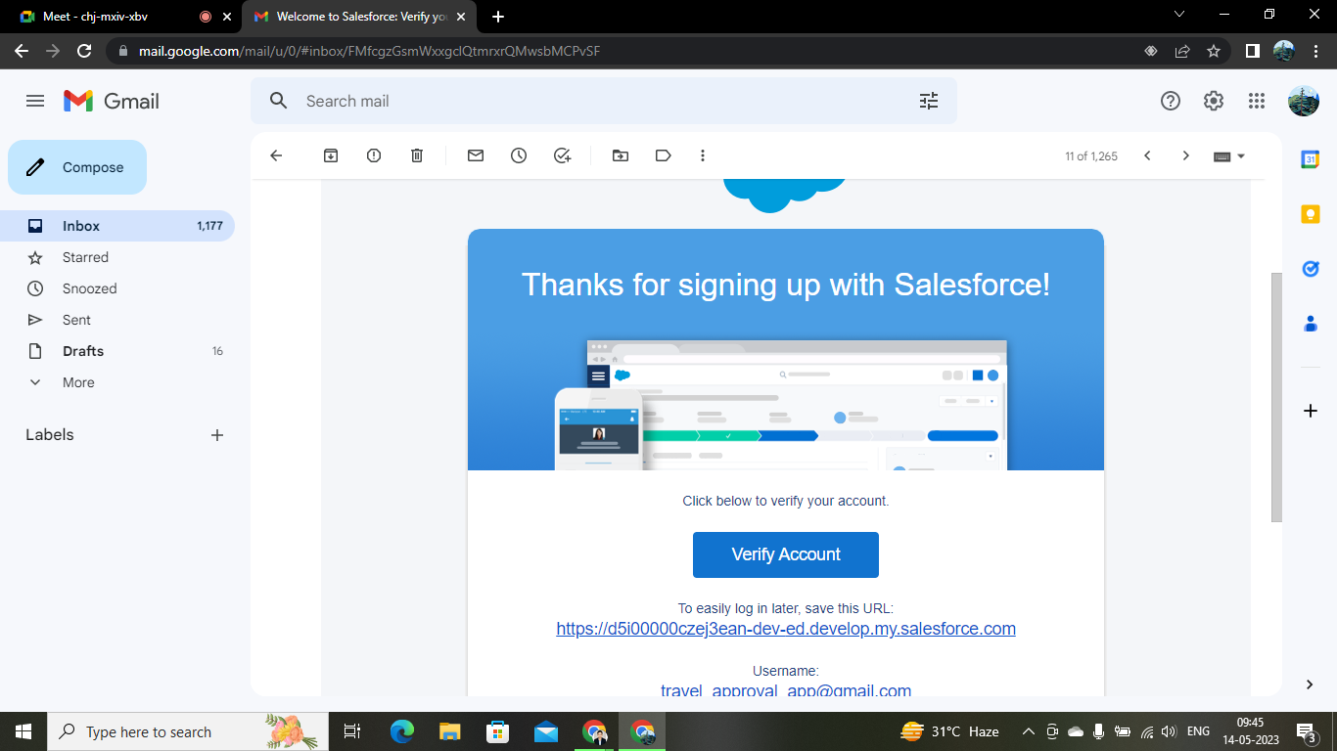

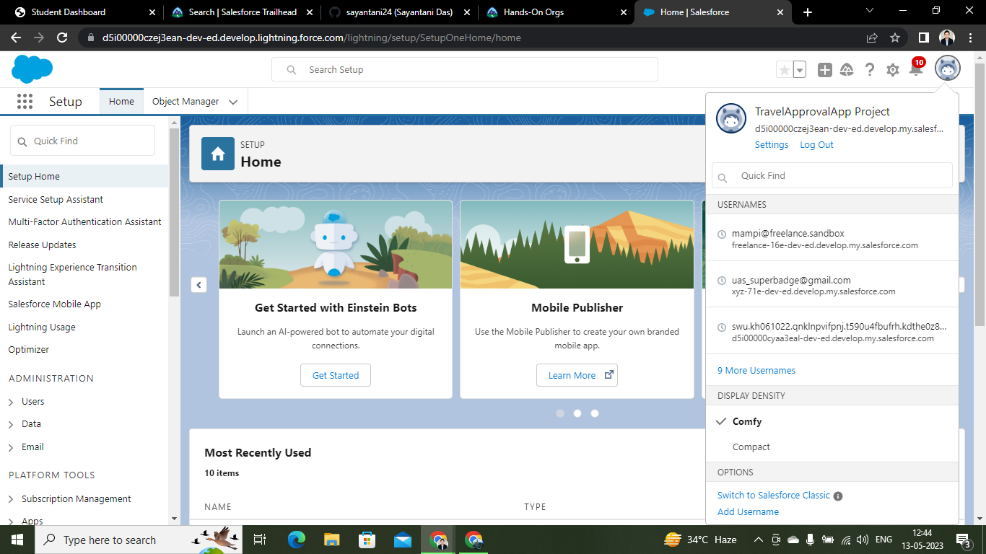

### **Object In Salesforce**

Salesforce objects are database tables that permit us to store data that is specific to an organization. Salesforce objects are of two types: Standard Objects: Standard objects are the kind of objects that are provided by salesforce.com such as users, contracts, reports, dashboards, etc.

Salesforce objects are of two types:

1. Standard Objects: Standard objects are the kind of objects that are provided by salesforce.com such as users, contracts, reports, dashboards, etc.
2. Custom Objects: Custom objects are those objects that are created by users. They supply information that is unique and essential to their organization. They are the heart of any application and provide a structure for sharing data.

**Creation Of Department Object For Travel Approval App**

For this Travel Approval we need to create a few objects like Department, Expense Items , Travel Approval etc.

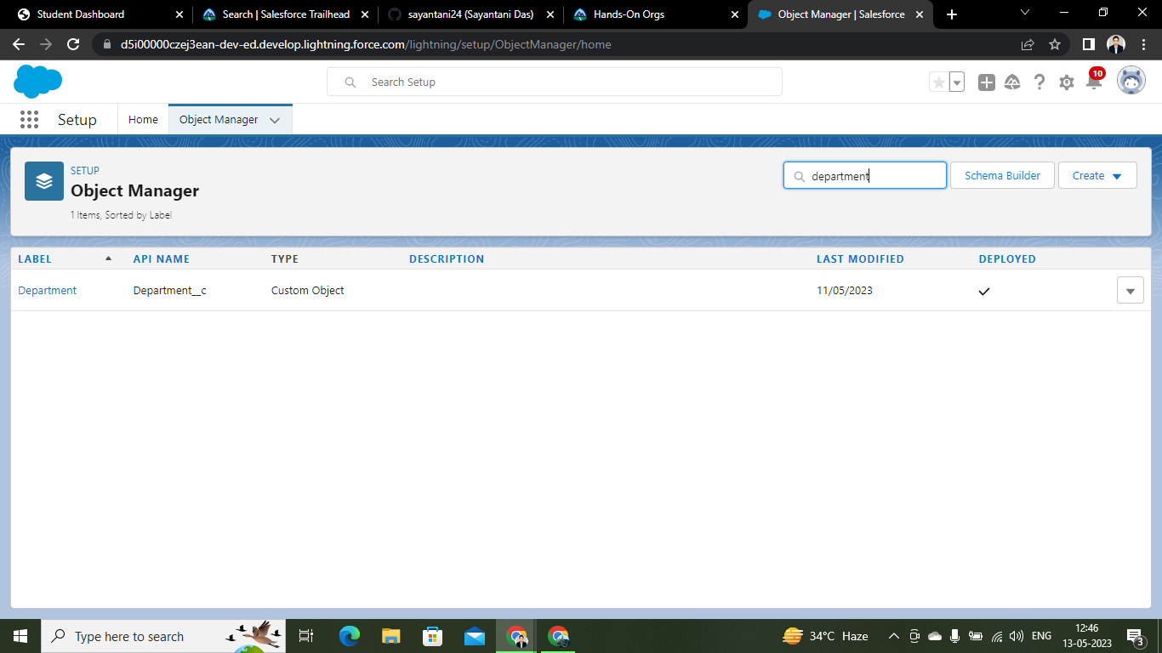

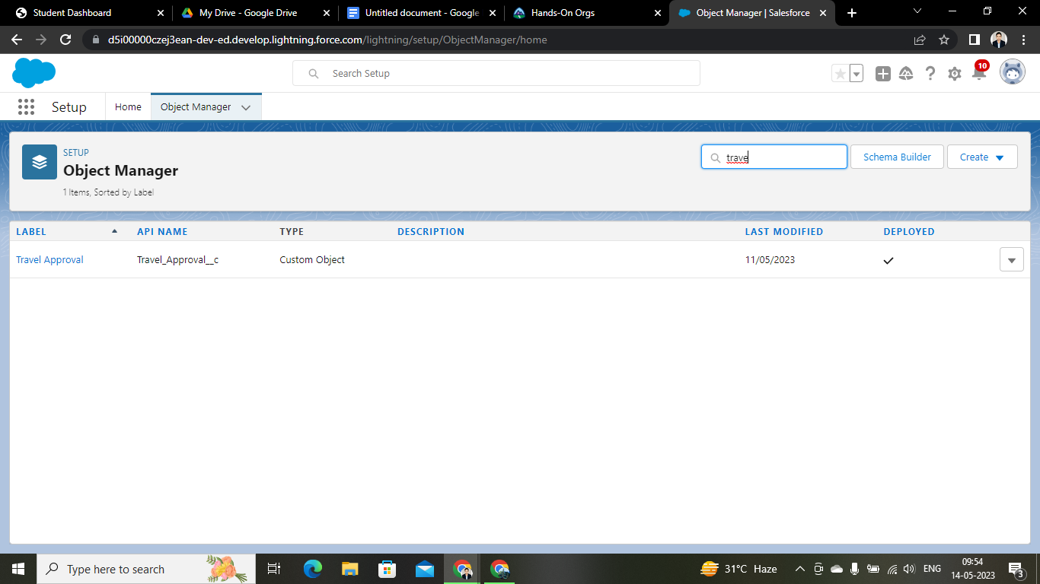

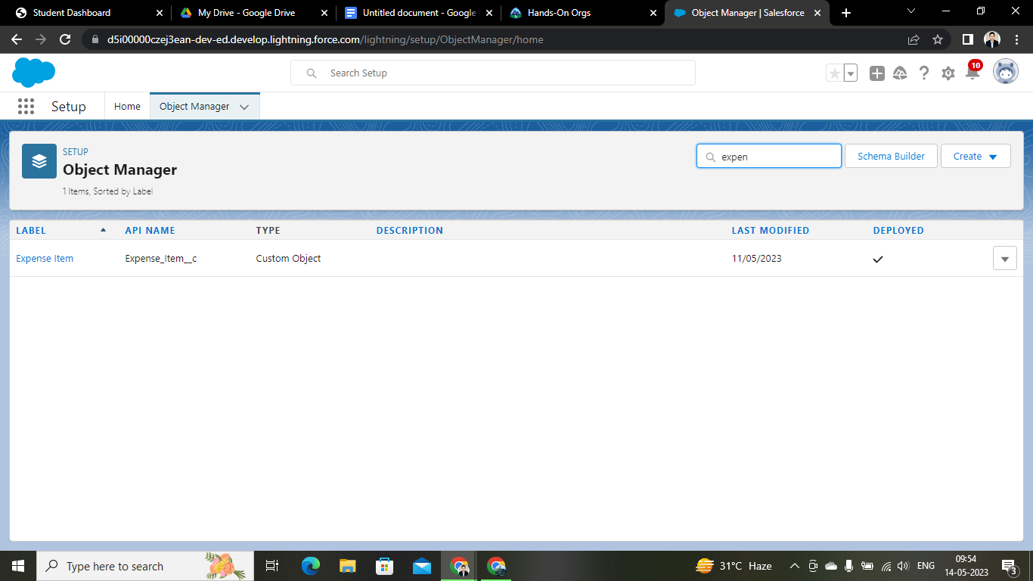

### **What Is A Tab?**

Tabs in Salesforce help users view the information at a glance. It displays the data of objects and other web content in the application.

There are mainly 4 types of tabs:

(A) Standard Object Tabs: Standard object tabs display data related to standard objects

(B) Custom Object Tabs: Custom object tabs displays data related to custom objects.

(C) Web Tabs: Web Tabs display any external Web-based application or Web page in Salesforce tabs.

(D) Visualforce Tabs: Visualforce Tabs display data from a Visualforce Page.

### **Custom Tab Creation**

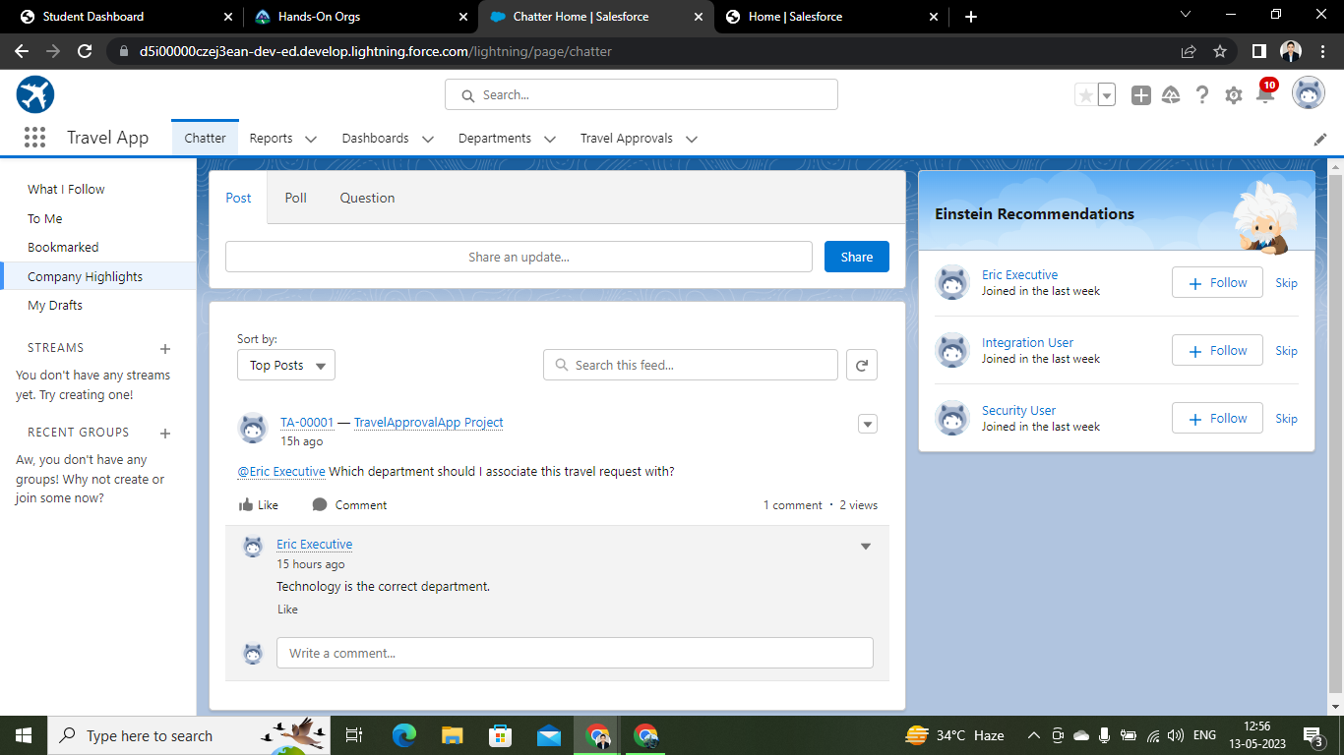

### 

### **Lightning App**

Apps in Salesforce are a group of tabs that help the application function by working together as a unit. It has a name, a logo, and a particular set of tabs. The simplest app usually has just two tabs.

There are two types of apps -

1. Standard App: Standard apps come with every occurrence of Salesforce as default. Many features like Sales, Marketing, Community, call center, content, Salesforce Chatter, App Launcher, etc are present in it.
2. Custom Apps: Custom apps are created according to the needs of the user. Custom Apps are made by using standard and custom tabs together.

### **Created Travel Approval App**

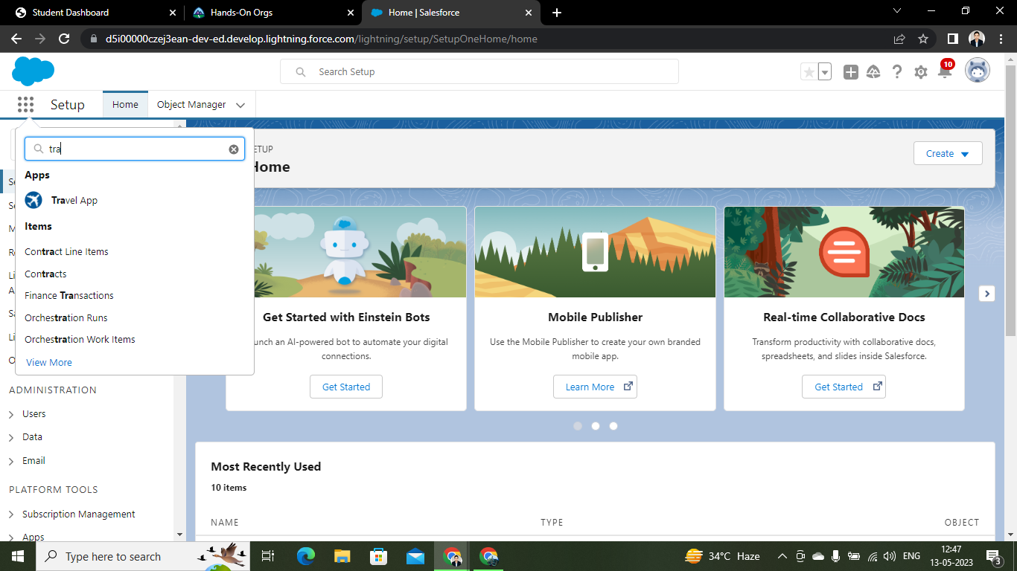

### **Fields And Relationships**

**Fields** - Fields store data values that are required for a particular object in a record.

An object relationship in Salesforce is a two-way association between two objects.

Relationships are created by creating custom relationship fields on an object. This is done so that when users view records, they can also see and access related data.

### **Creation Of Fields For The Department Object & Lookup Relationship With Department :**

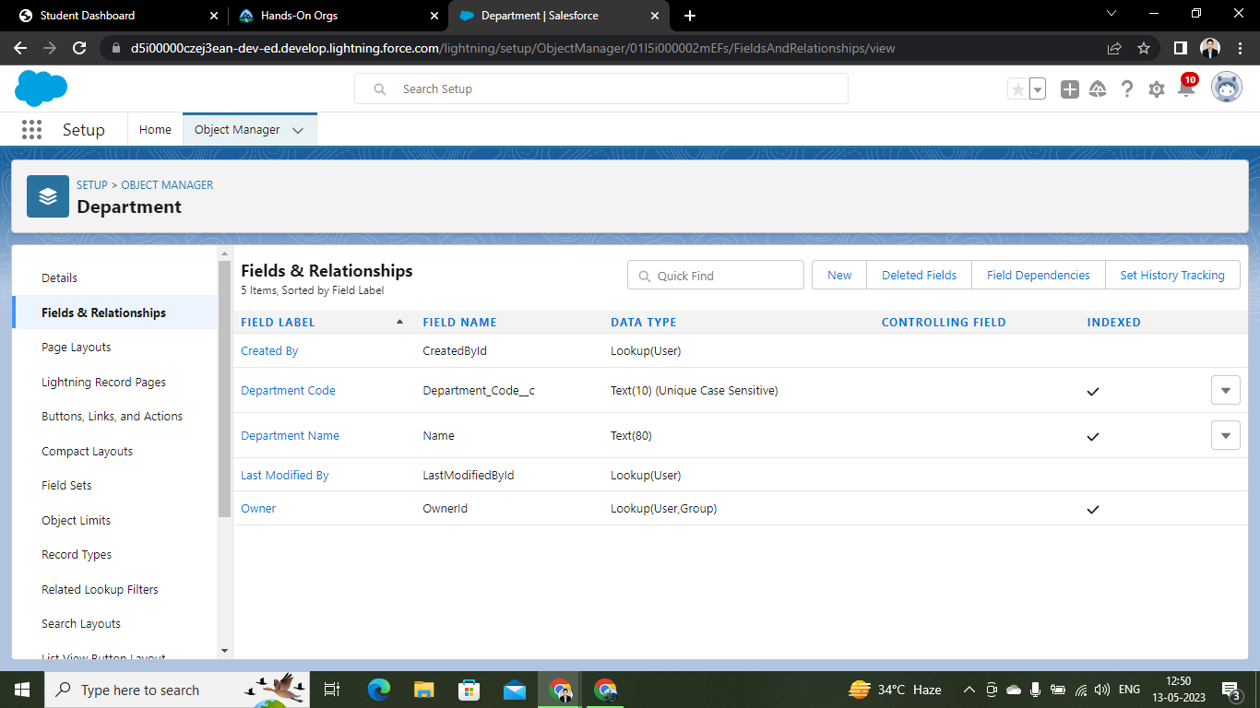

### **Fields For The Expense Item Object & Roll Up Summary Fields On Expense Object :**

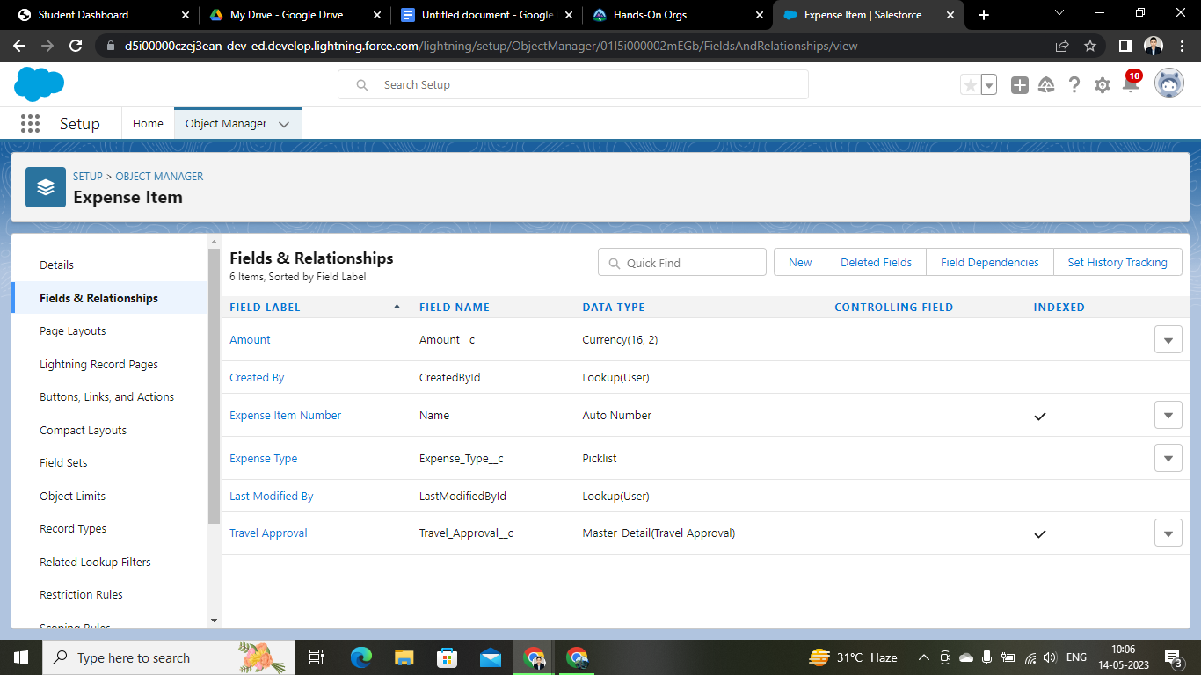

### 

### **Fields For The Travel Approval Object:**

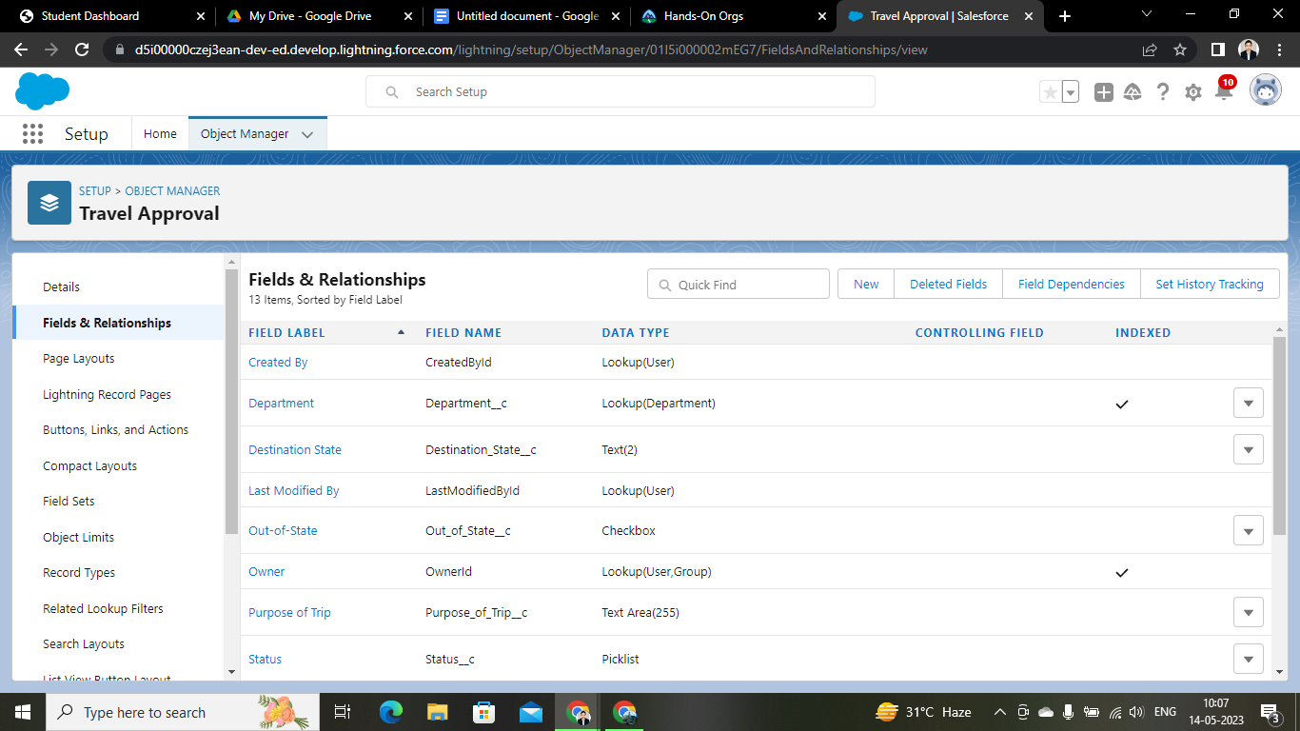

### **Pick List Fields of Expense Item Object:**

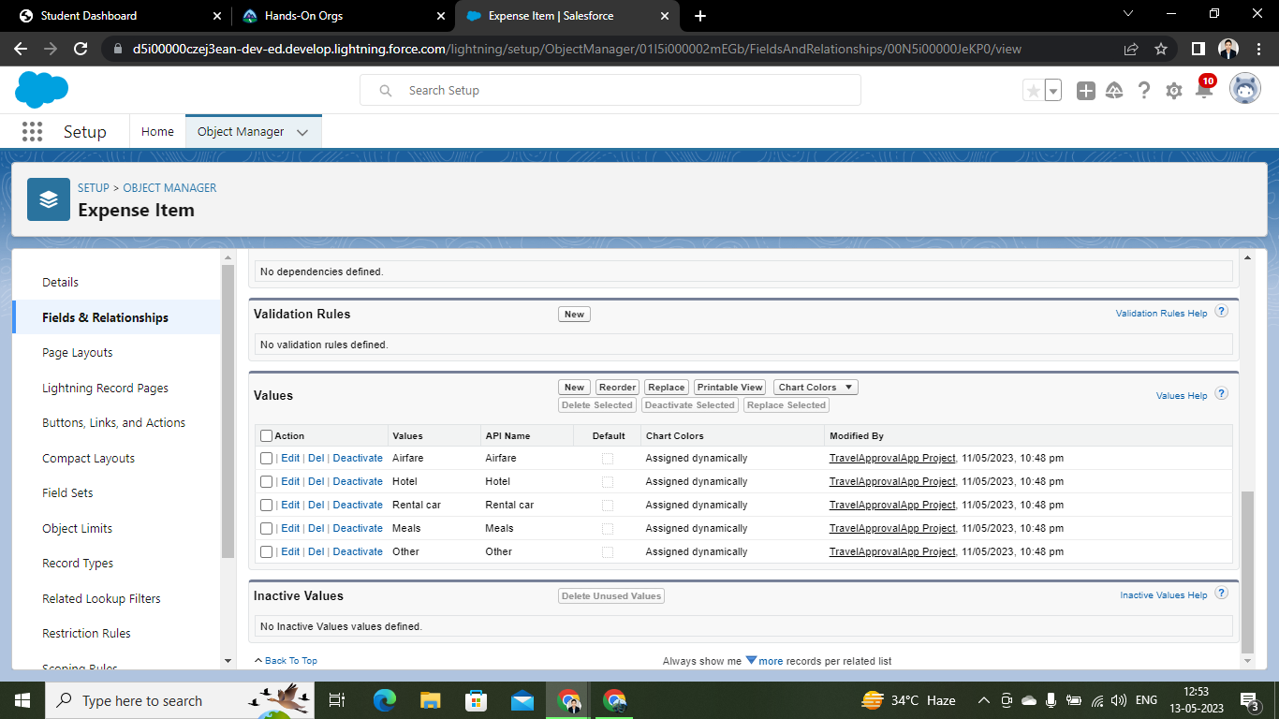

### **Import Departments**

Data Import lets us upload data from external sources and combine it with data we collect via Analytics. We can then use Analytics to organize and analyze all of our data in ways that better reflect our business.

The Data Import Wizard is a Tool that makes it easy to import data for many standard Salesforce objects, including accounts, contacts, leads, solutions, campaign members, and personal accounts. We can also import data for custom objects.

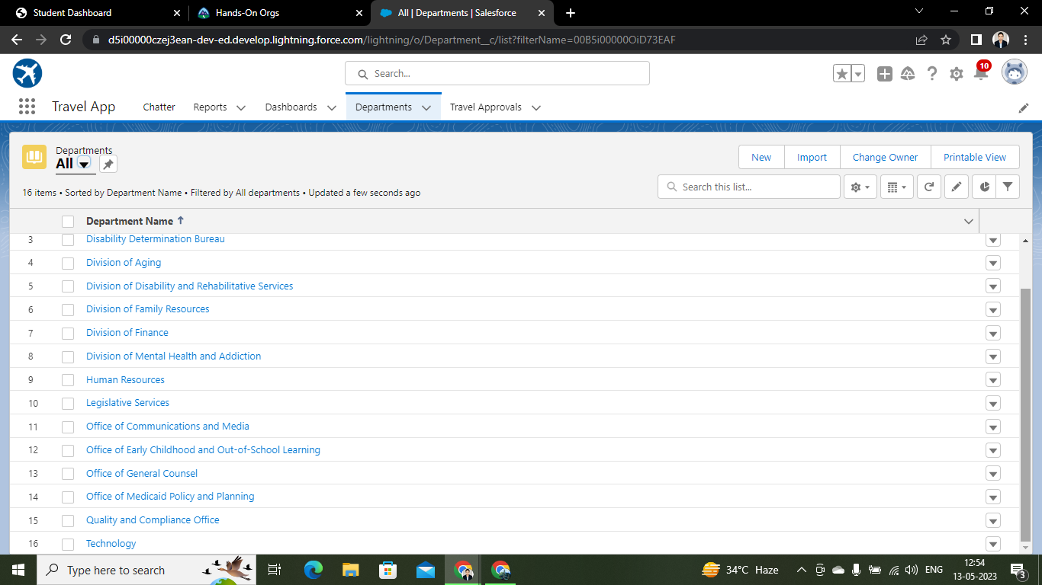

## **Users**

**A user is anyone who logs into Salesforce.**

Users are employees at our company, such as sales reps, managers, and IT specialists, who need access to the company's records. Every user in Salesforce has a user account.

### **Creating A User In Salesforce**

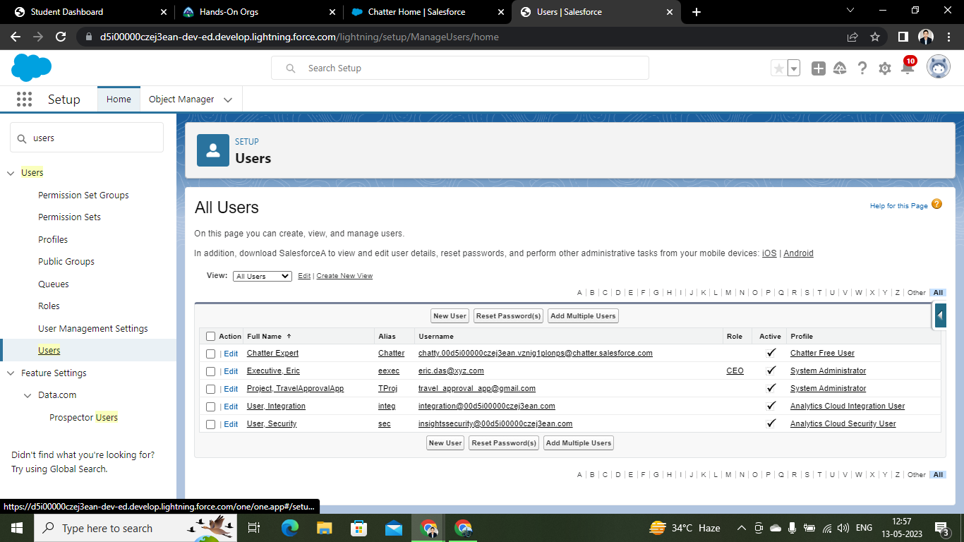

### **Use Customization**

Customization refers to custom software development and coding to add robust features to your CRM platform. These features can be integrated with our business to have a scalable impact.

### **Customize Travel Approval Object Page Layout**

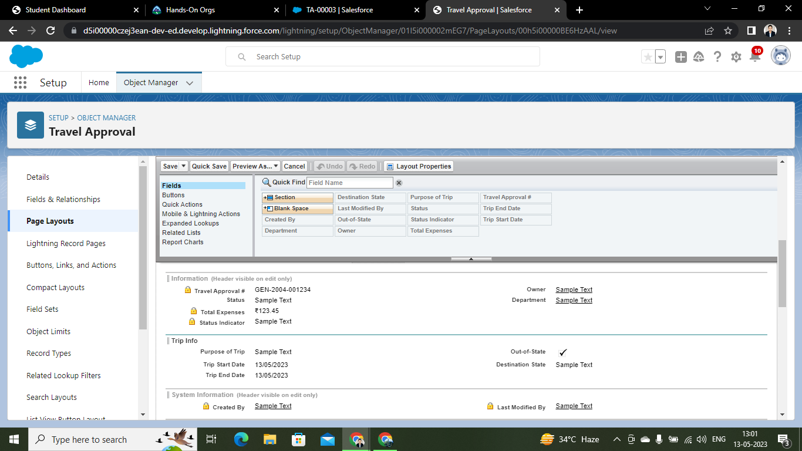

### **Add Business Logic To Travel App**

**Validation Rule** - It can contain a formula or expression that evaluates the data in one or more fields & returns a value of true or false. Validation Rules also include an error message to display to the user when the rule returns a value true due to an invalid value/data.

### **Creating Validation Rule & Creating Formula Fields**

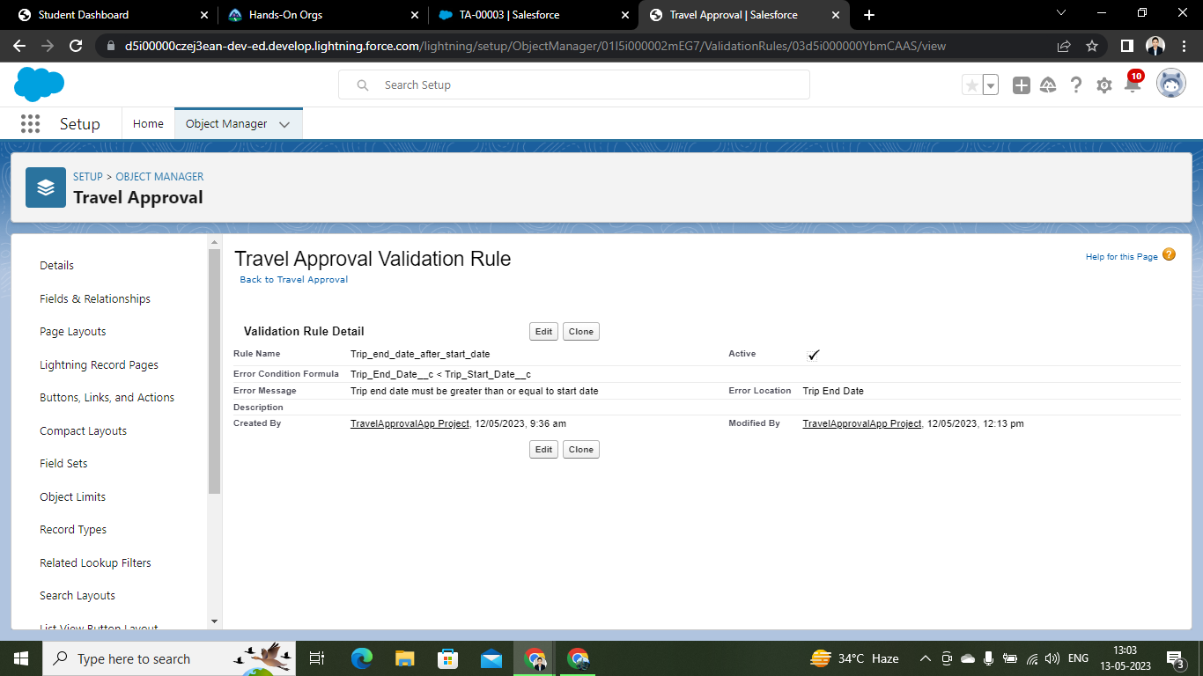

### **User Adoption - Create Record**

**Create Records**

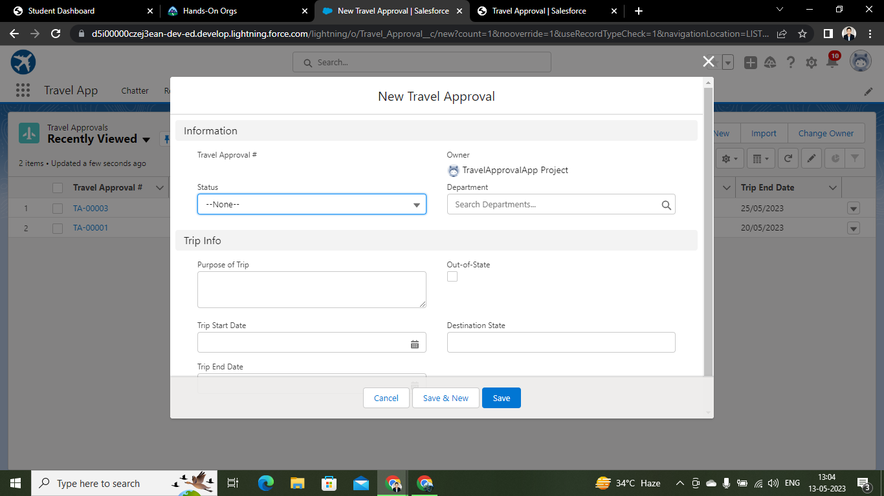

**View record**

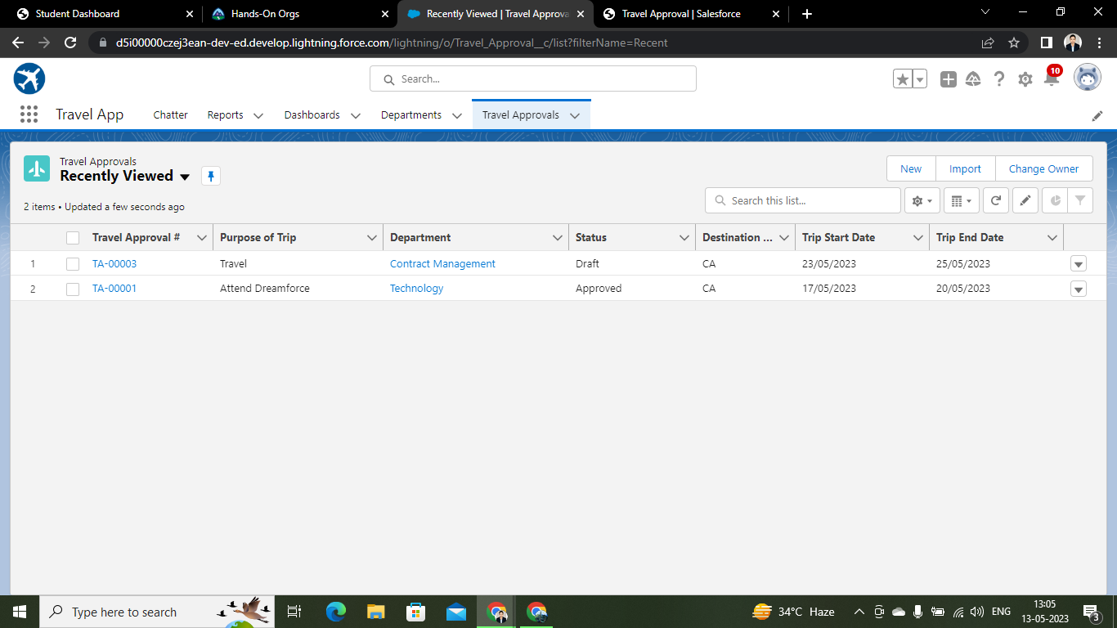

**Delete record**

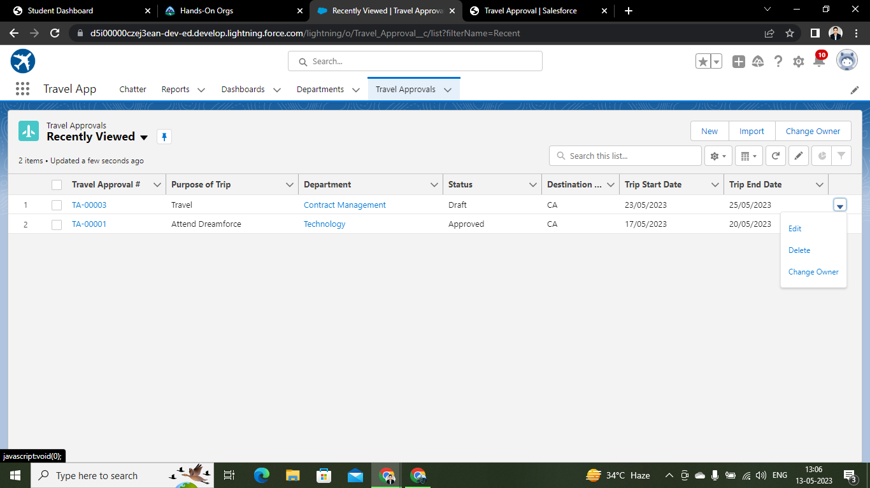

### **What Are Reports?**

Reports in Salesforce is a list of records that meet a particular criterion which gives an answer to a particular question. These records are displayed as a table that can be filtered or grouped based on any field.

There are 4 types of report formats in Salesforce:

1.Tabular Reports:

This is the most basic report format. It just displays the row of records in a table with a grand total. While easy to set up they can’t be used to create groups of data or charts and also cannot be used in Dashboards. They are mainly used to generate a simple list or a list with a grand total.

1. Summary Reports: It is the most commonly used type of report. It allows grouping of rows of data, view subtotal, and creating charts.
2. Matrix Report: It is the most complex report format. Matrix report summarizes information in a grid format. It allows records to be grouped by both columns and rows. It can also be used to generate dashboards. Charts can be added to this type of report.
3. Joined Reports: These types of reports let us create different views of data from multiple report types. The data is joined and reports are organized in blocks. Each block acts as a subreport with its own fields, columns, sorting, and filtering. They are used to group and show data from multiple report types in different views.

Report types:

Report type determines which set of records will be available in a report. Every report is based on a particular report type. The report type is selected first when we create a report. Every report type has a primary object and one or more related objects. All these objects must be linked together either directly or indirectly.

1. A report type cannot include more than 4 objects.
2. Once a report is created its report type cannot be changed.

There are 2 types of report types:

1. Standard Report Types: Standard Report Types are automatically included with standard objects and also with custom objects where “Allow Reports” is checked.

Standard report types cannot be customized and automatically include standard and custom fields for each object within the report type. Standard report types get created when an object is created, also when a relationship is created.

1. Custom Report Types: Custom report types are reporting templates created to streamline the reporting process. Custom Reports are created by an administrator or User with “Manage Custom Report Types” permission. Custom report types are created when standard report types cannot specify which records will be available on reports.

In custom report types we can specify objects which will be available in a particular report. The primary object must have a relationship with other objects present in a report type either directly or indirectly.

There are 3 types of access levels of folders:

1. Viewer: With this access level, users can see the data in a report but cannot make any changes except cloning it into a new report.
3. Editor: With this access level, users can view and modify the reports it contains and can also move them to/from any other folders they have access level as Editor or Manager.
4. Manager: With this access level, users can do everything Viewers & Editors can do, plus they can also control other user’s access levels to this folder. Also, users with Manager Access levels can delete the report.

**Create reports**

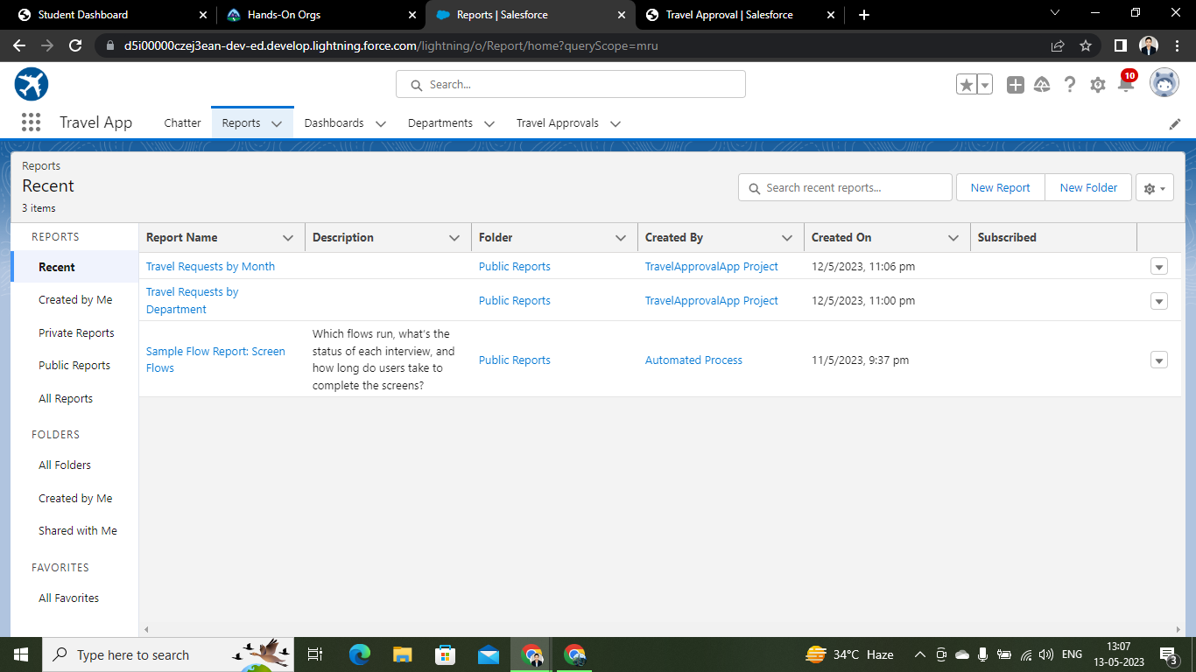

### **View Reports**

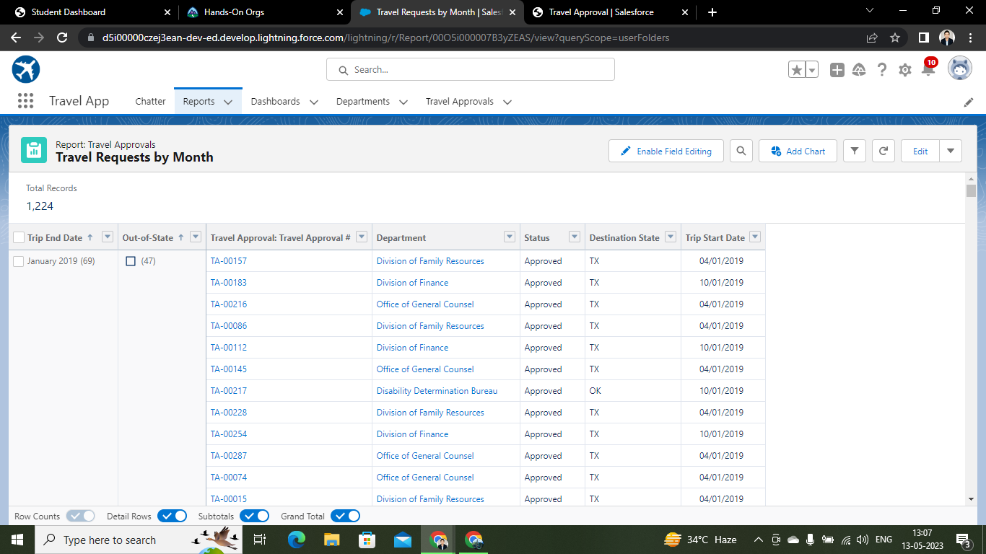

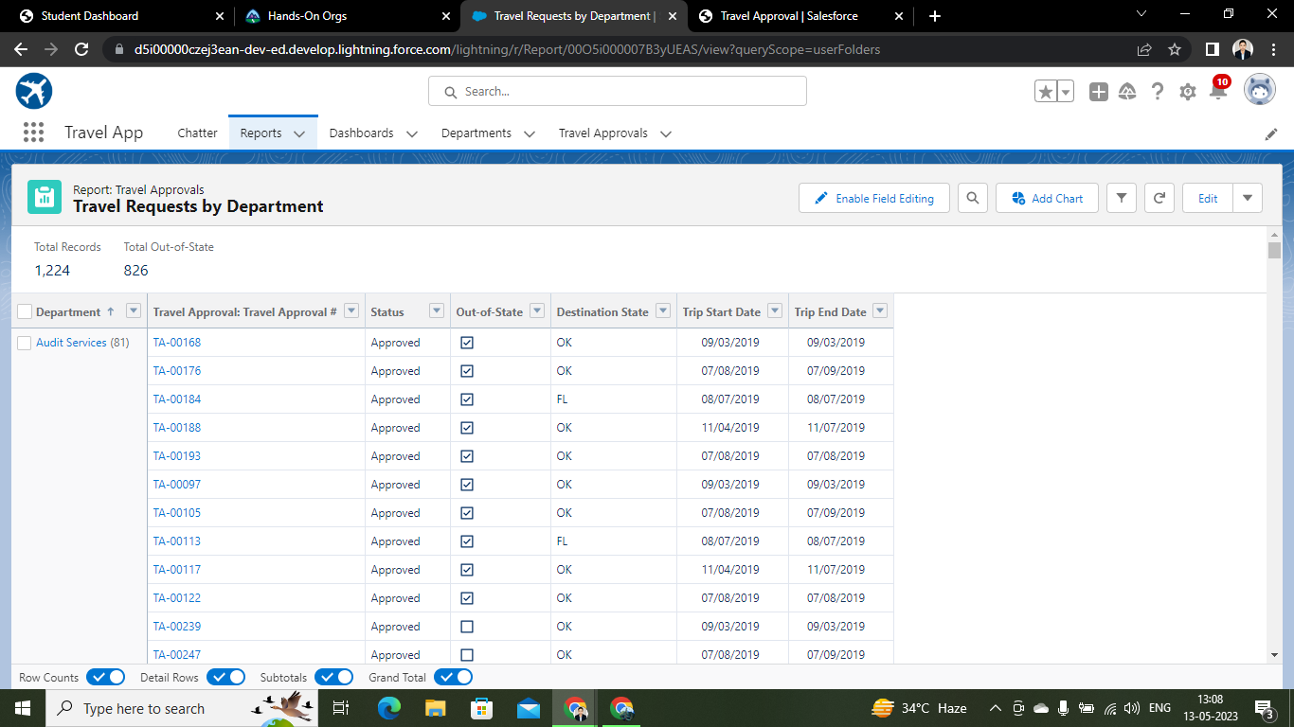

### 

### **Dashboards**

### Dashboards let uu curate data from reports using charts, tables, and metrics. If our colleagues need more information, then they're able to view your dashboard's data-supplying reports. Dashboard filters make it easy for users to apply different data perspectives to a single dashboard.

### **Create Dashboard**

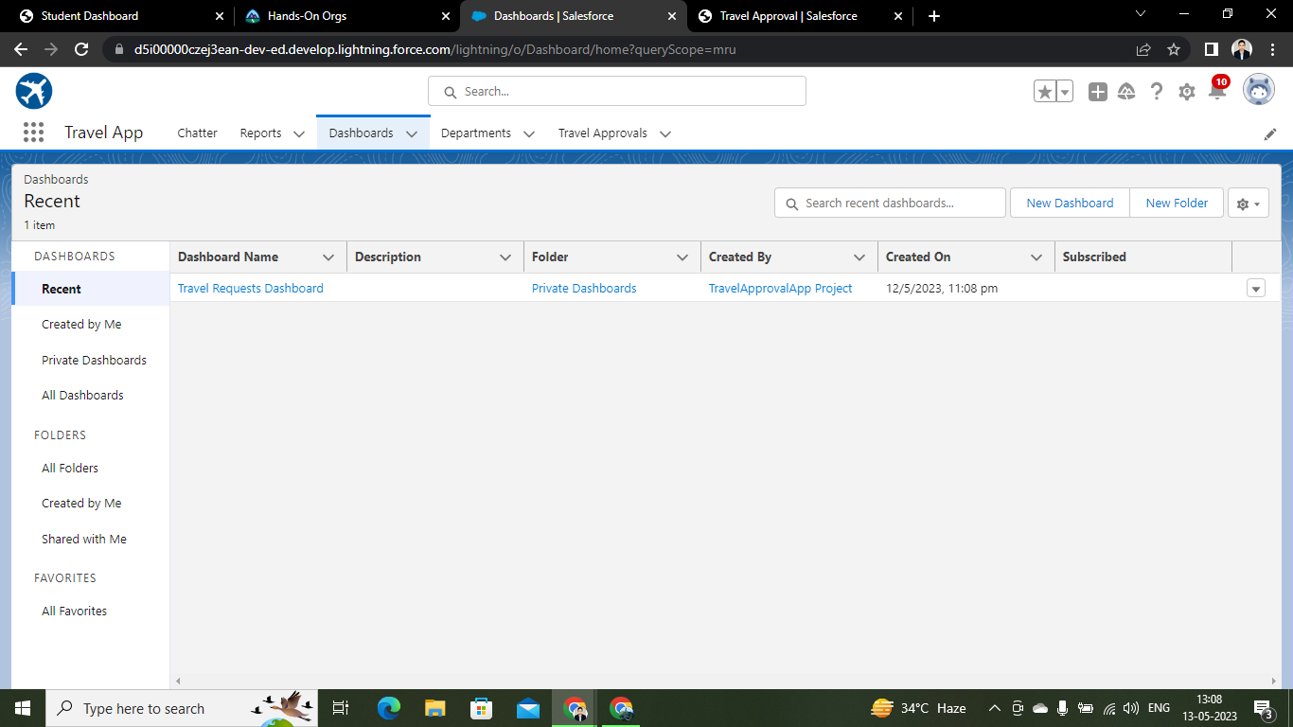

**View dashboards**

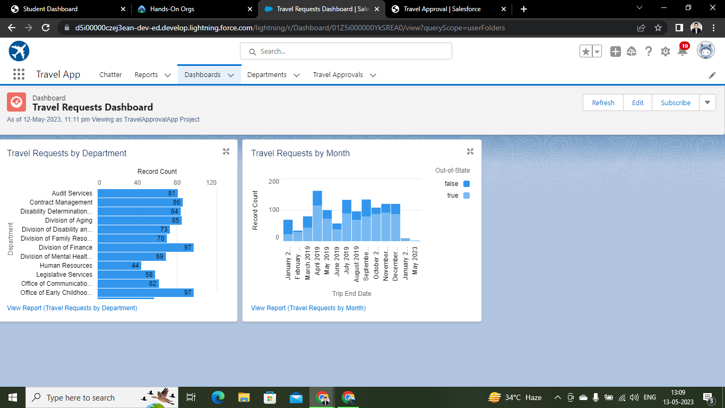

Name: SAYANTANI DAS

Trailhead Link: <https://trailblazer.me/id/sdas04>

Video Demonstration Link: <https://drive.google.com/file/d/10zSBy-6WXOhL-2OWSLL6aTMHknzXtINj/view?usp=share_link>